**Figure 1.** A) Temperature and predation directly and indirectly affect population density and metabolic rates in aquatic communities. In our experimental communities, predation directly (solid lines) affects the abundance, size and species composition of prey, and predation by notonectids on grazers leads to an indirect effect (dashed line) called a trophic cascade on algal abundance. Temperature directly affects per capita metabolic rates (solid lines), and indirectly affects algal abundance (dashed lines) by increasing grazing rates. Other indirect effects of temperature are possible, but not shown. B) Experimental communities varied in their trophic structure. Ten communities included algae only (A), 10 comprised algae + grazers (AG), and 10 included algae + grazers + predators (AGP). Temperature has direct effects (solid lines) on oxygen production and consumption and growth rates of all taxa.

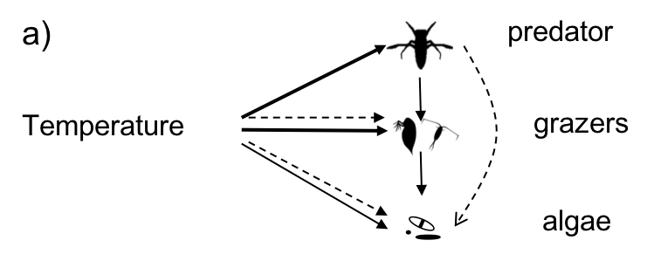

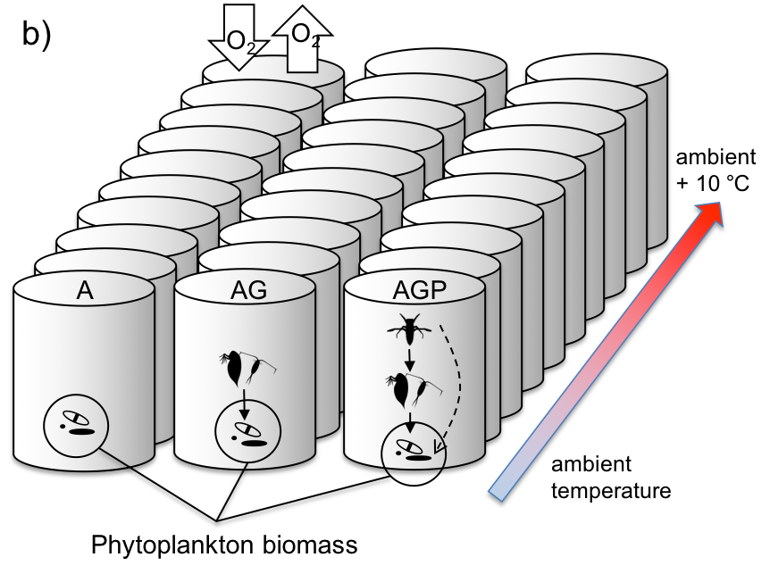

**Figure 2: A**) Estimated phytoplankton biomass (chlorophyll a concentration) declined with increasing temperature, and varied with trophic structure. Lines are estimated effects of temperature on phytoplankton biomass based on linear mixed effects models (Eqn 11) for equation 3b with and without temperature dependence in model terms for the intercept and slope (*ER*). The intercept and slope of each line was estimated by pooling terms from the statistical model (Table 1) for the intercept and temperature dependence in eqn 11 (see Methods). All observations for phytoplankton biomass are shown in Fig 6. **B**) Strength of the trophic cascade at a given temperature was estimated by taking the log ratio of algal biomass (estimated as chlorophyll *a* concentration) in the presence of predators and grazers (AGP) vs the algal abundance in the presence of grazers only (AG) (Model results in Table 2). Lines represent fitted effects of temperature, centered on the grand mean of all recorded ecosystem temperatures (Eqn 12). **C)** Temperature affected algal community composition in experimental ecosystems. Non-metric multidimensional scaling plot (NMDS) of temporal phytoplankton taxanomic composition for all temperature treatments and trophic levels (Taxa listed in Table SX). Taxonomic abundances are square root transformed. Each point represents one ecosystem observed at one time, and lighter colours are communities at higher temperatures. NMDS is an iterative search for positions of species, time, temperature and food chain length on few dimensions (axes) that minimizes departure from monotonicity in the association between distance (dissimilarity) in the original data and ordination space. Ovals indicate … Jessica may be able to make the NMDS plot for each trophic treatment. I may be able to make a plot for the ratio of Cyanos vs noncyanos.

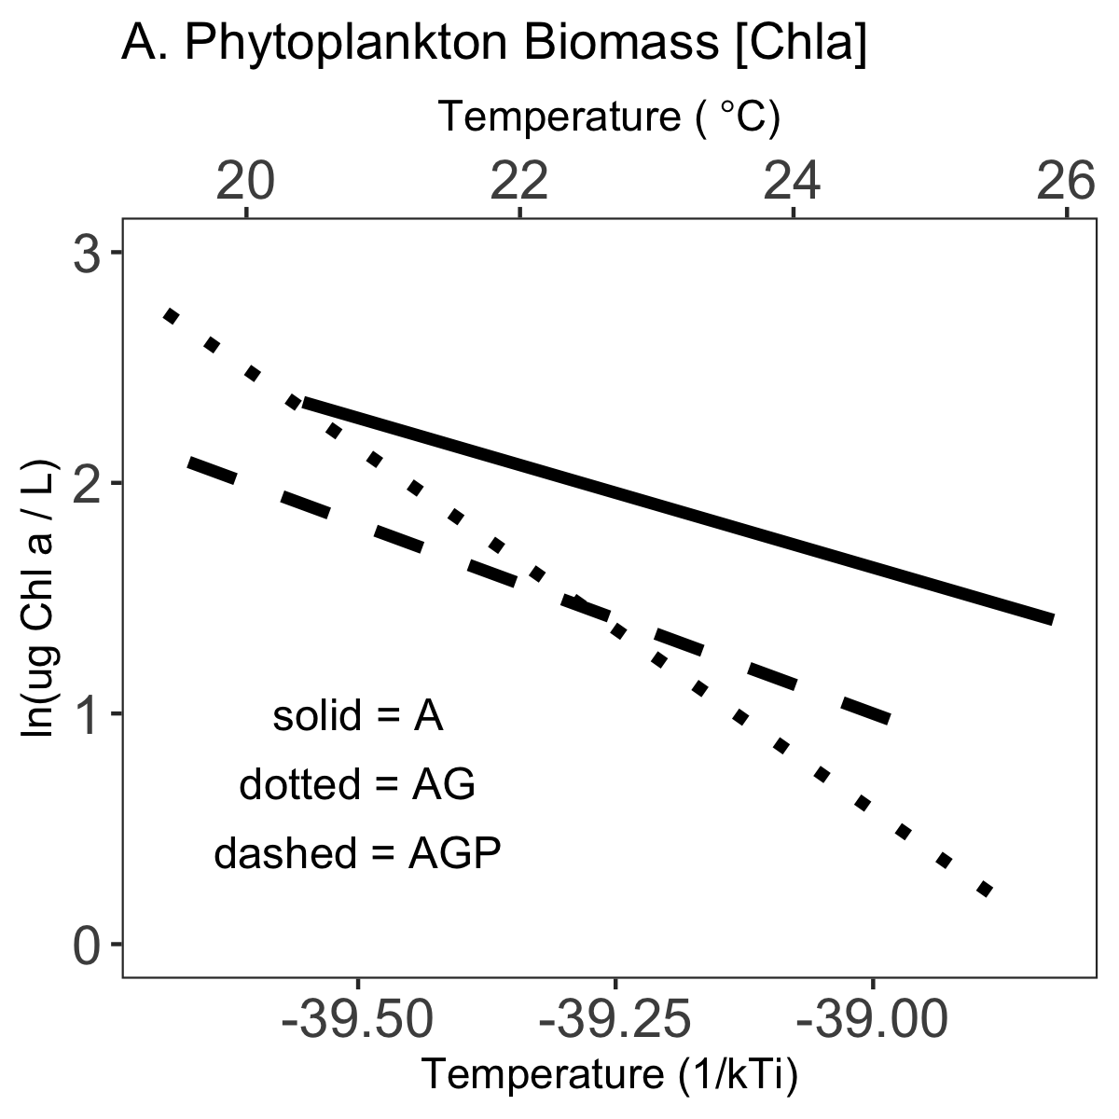 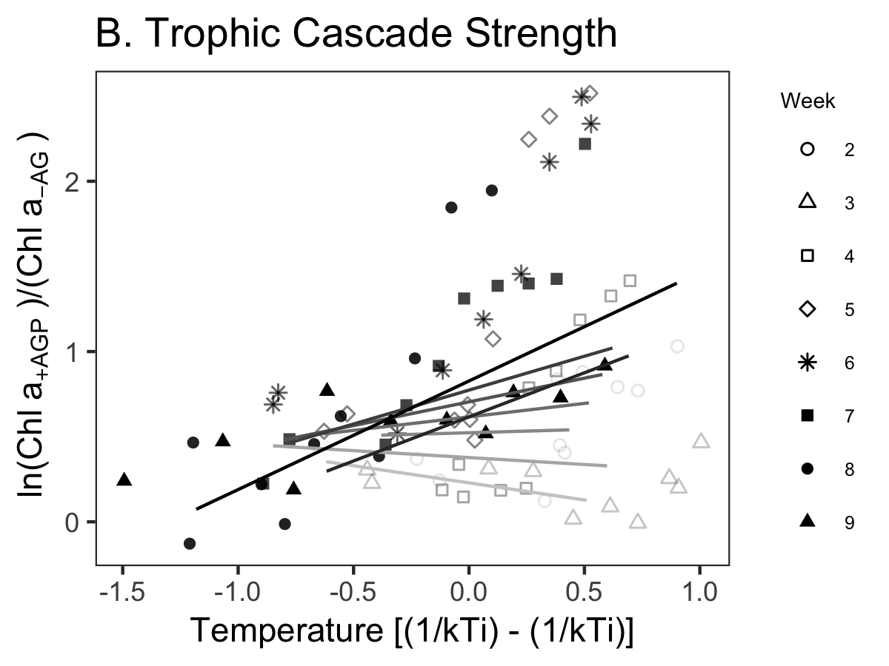

**C.**

**Aooendix NMDS.tif**

**Figure 3.** Comparison of estimated temperature dependences of phytoplankton biomass (Mb), net ecosystem production (NEP), ecosystem respiration (ER) for communities with algae only (A), algae and grazers (AG) and algae, grazers and predators (AGP). Composite estimates of temperature dependences as shown in Figures 2A and 3, achieved by adding temperature terms in the best models (see Methods), and estimated confidence intervals. No temperature dependence is indicated by the dashed line, and the gray dotted lines indicate + 0.65 and 0.32 eV, expected temperature dependences of photosynthesis and respiration.

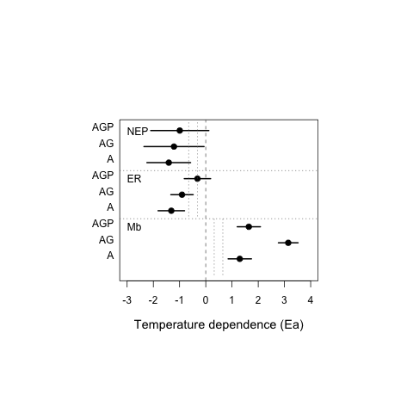

**Figure 4: A)** Total zooplankton density (ind / 10L), comprising *Daphnia* and copepod taxa,declined with increasing temperaturebut not with predator presence. B) *Daphnia* density (ind/L) declined with temperature and with predators (Table 4), and C) copepod spp density (ind/L) declined with temperature but not predators (Table 5). Lines are regression fits with negative bionomial (total zooplankton) or Poisson (Daphnia, copepods) zero-inflated error structures with ecosystem as a random effect for ecosystems with predators (gray dashed line) and without predators (black solid line). Each datapoint is an observed total zooplankton density for crustacean taxa (*Daphnia* and copepods) in each ecosystem on a sampling date.

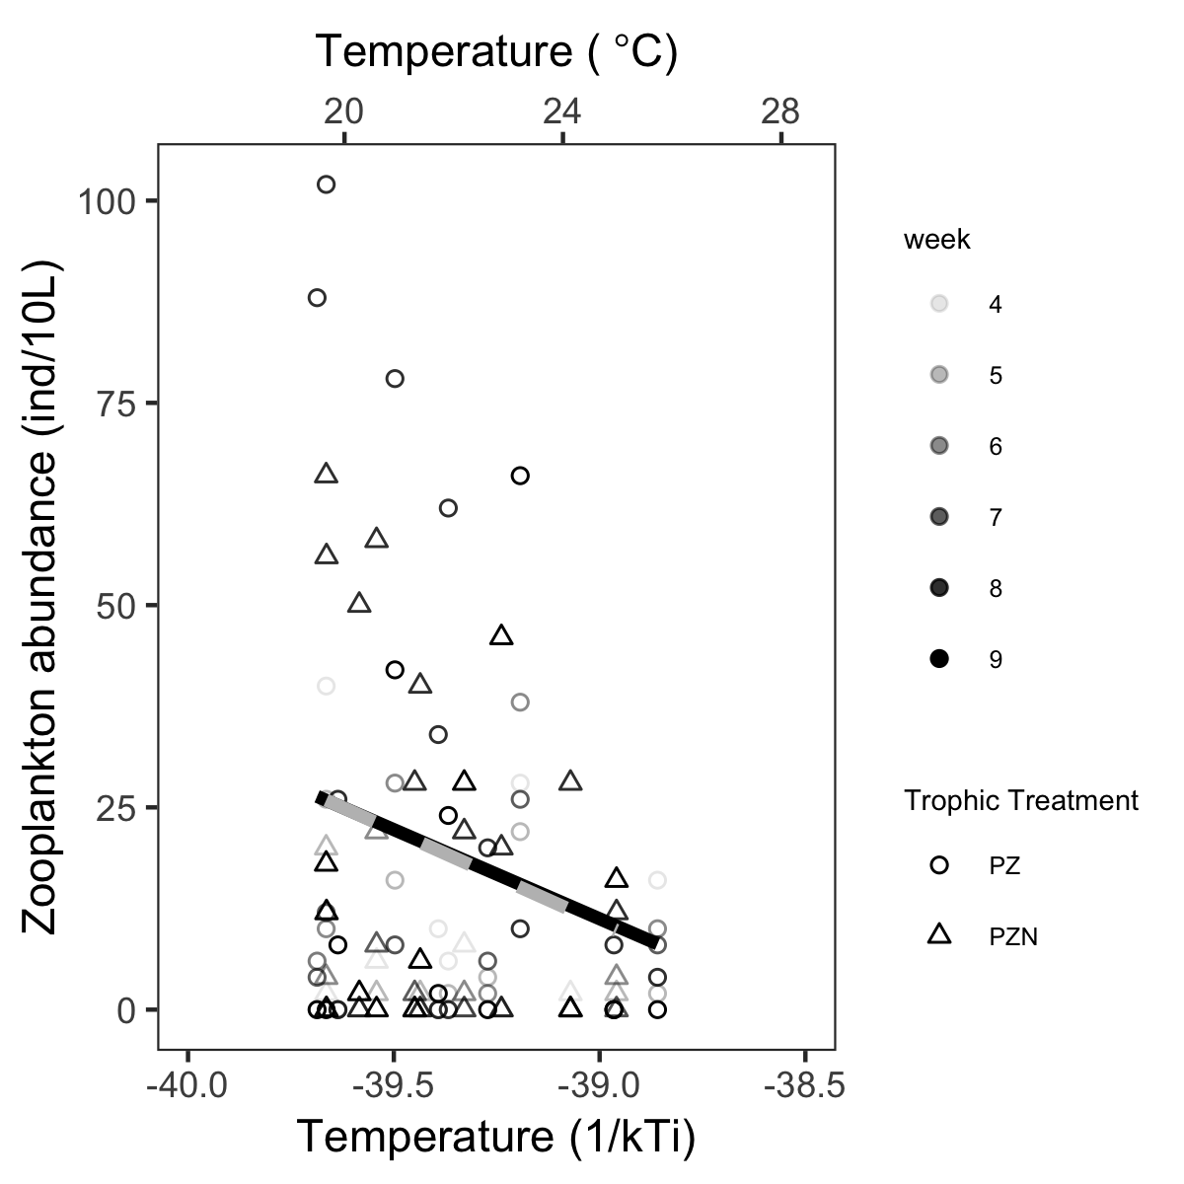

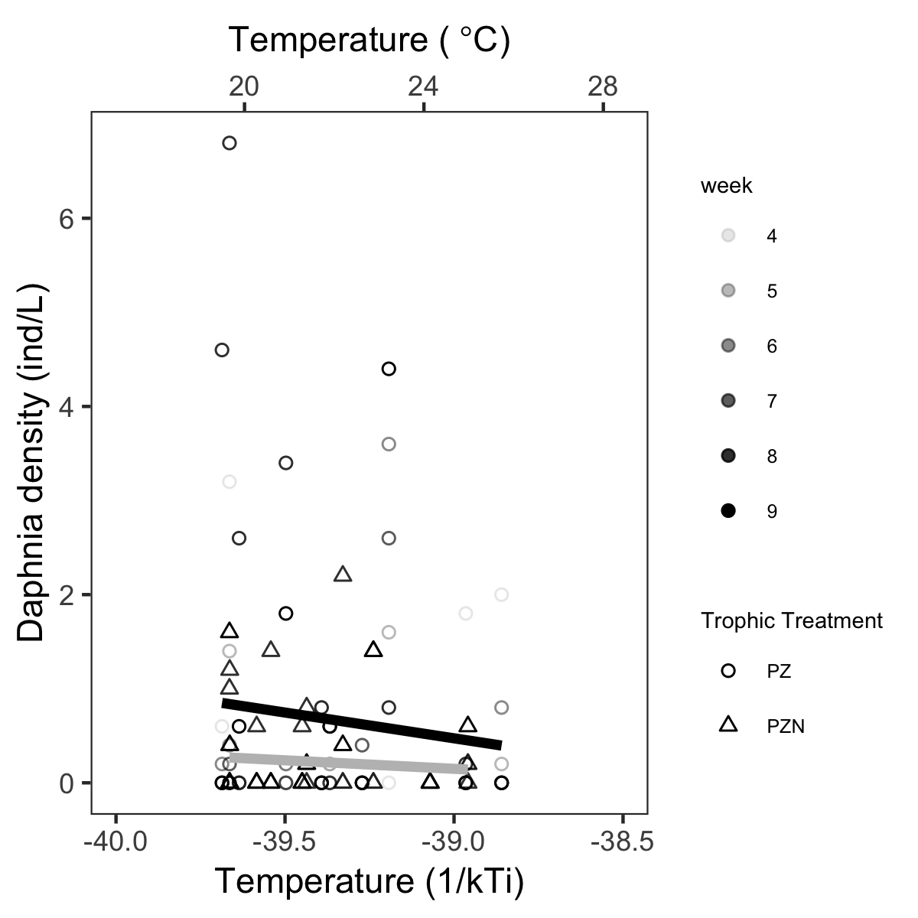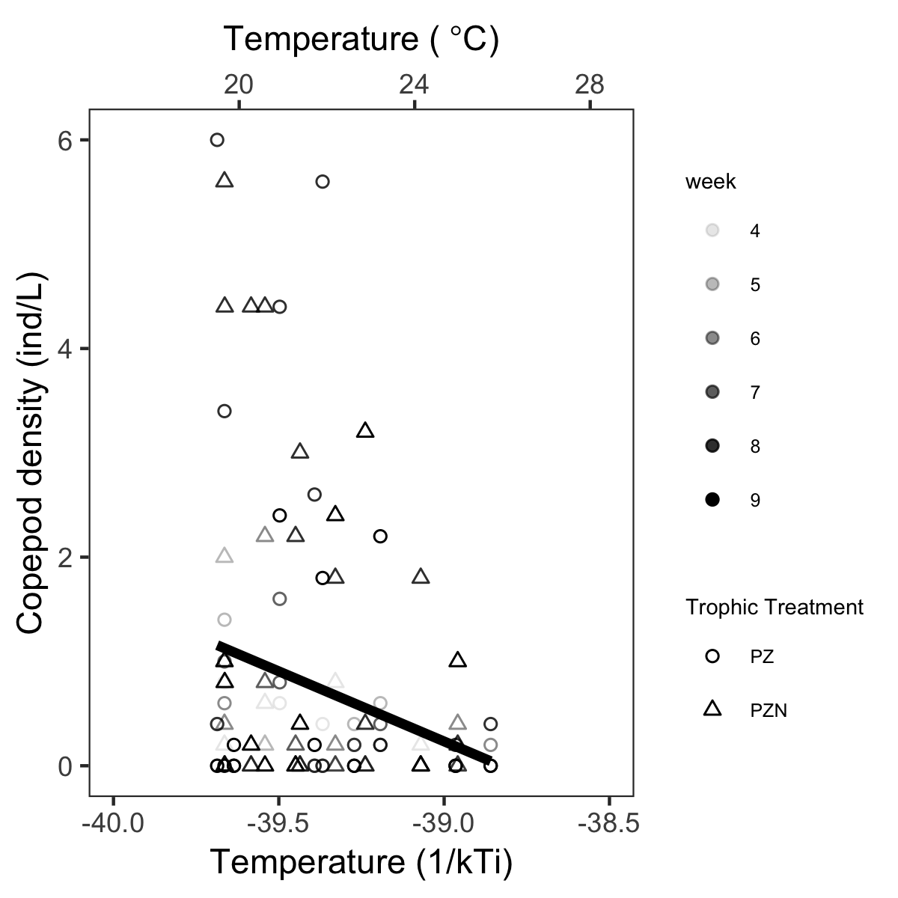

**Figure 5:** The effect of mean ecosystem temperature on A) phytoplankton biomass, B) net ecosystem productivity (NEP), and C) net ecosystem respiration (ER) for three community types that varied in their trophic interactions: i) algae-only (A), ii) algae + grazers (AG), and iii) algae + grazers + notonectid predators (AGP). Black lines indicate the among-ecosystem effects of temperature, modelled by equation 5 using hierarchical regressions fit to among-ecosystem variation in temperature, after taking into account within-group variation temperature effects (light lines) (Table 2), and may be compared with predicted effects of temperature and species interactions depicted in Figure 1. Activation energies and confidence intervals estimated by best model or best model set (Table 1, Supplementary Material 2). Temperature in Celsius is shown for comparison only, models were fit to inverse temperature. For clarity here, the three trophic treatments are separated into three rows of panels. Response variables were estimated once per week (for 6 weeks post bloom) in each replicate ecosystem (n = 30). For each ecosystem (shade of grey), 6 points are shown, one point for each week (symbols). Temperatures within tanks declined over time (Fig S1.1C).

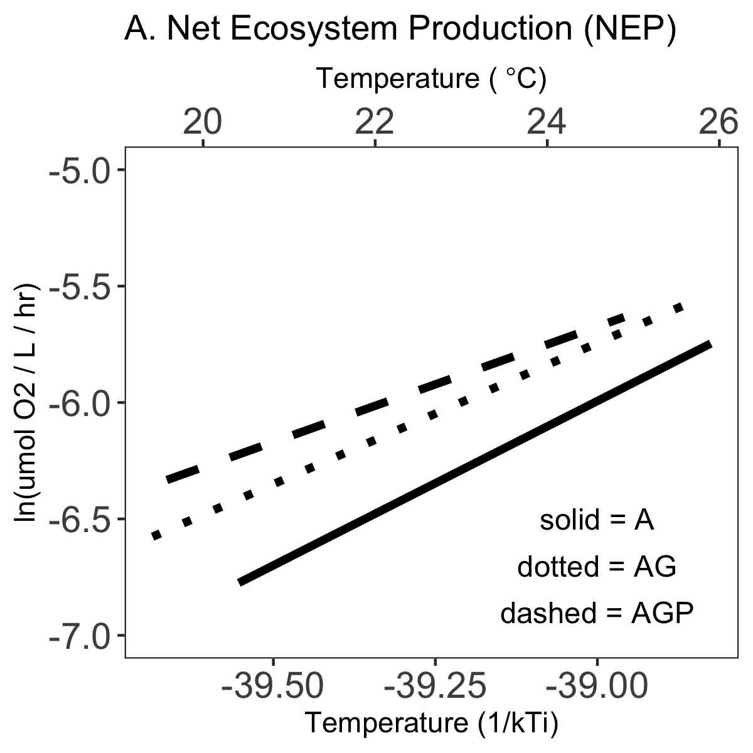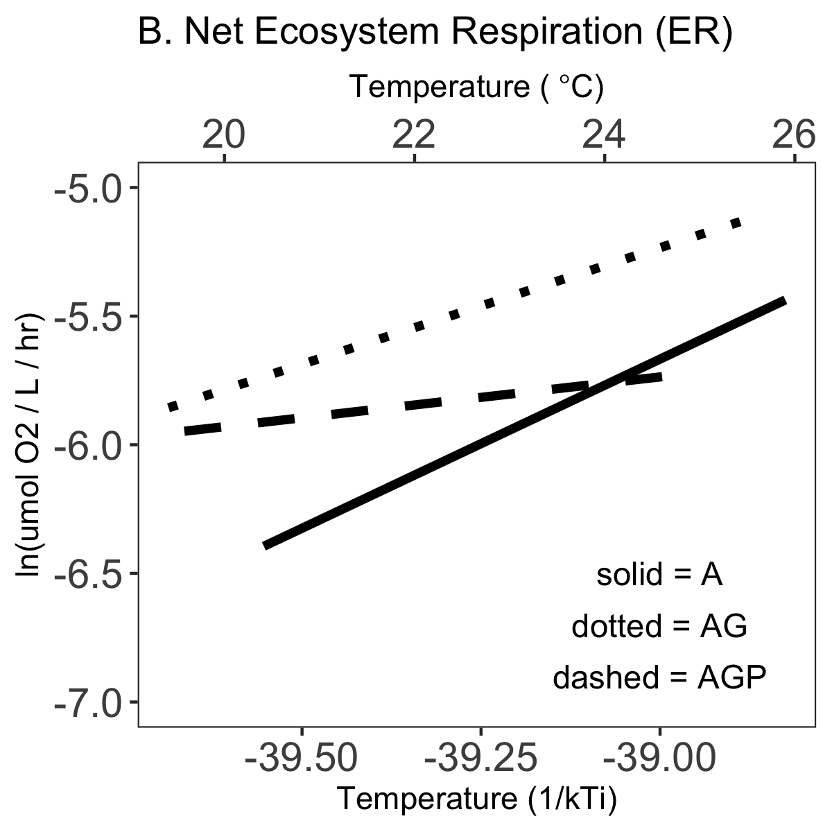

Figure 6. The effect of ecosystem temperature (Tij) on A) phytoplankton biomass, B) net ecosystem productivity (NEP), and C) net ecosystem respiration (ER) for three community types that varied in their trophic interactions: i) algae-only (A), ii) algae + grazers (AG), and iii) algae + grazers + notonectid predators (AGP). Each ecosystem *j* experienced different temperatures each of the 9 weeks of the experiment, and we also modelled variation in how response variables depended on weekly temperatures (Eqn 12). Blue lines indicate within-ecosystem temperature effects estimated from best models in Tables 2, 7 and 8, and black lines indicate the modelled among-ecosystem effects of temperature (Tables 1, 7, 8; Fig 2, 4). Temperature in Celsius is shown for comparison only, models were fit to inverse temperature. Temperatures within tanks declined over time (Fig S1.1C).

